Typical user

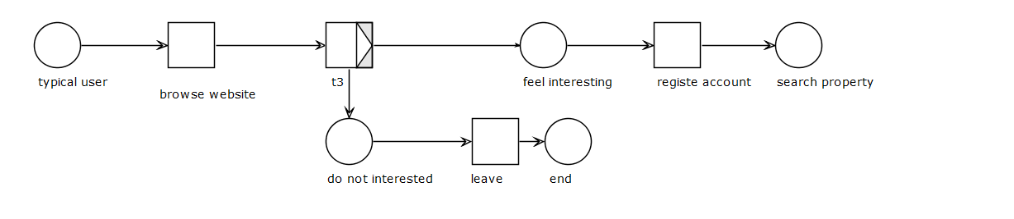

Student user

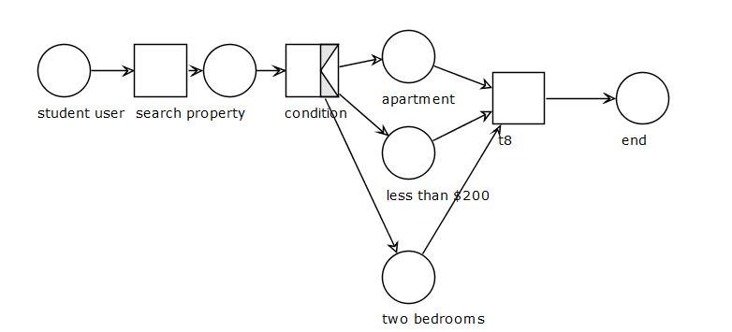

Web administrator user

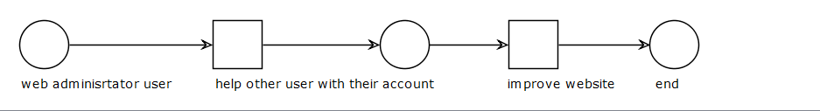

Property staff user

